New

Jersey

Immunization

Information

System

(NJIIS)

Interface Specifications
Table of Contents

Introduction 3
Instructions for NJIIS Interface 3
NJIIS Interface Enrollment Form (Draft) 5
XML File Format 6
Elements 7
Schema Used 8
Sample Interface File Record 15
NJIIS Data Elements Diagram 17
Delimited File Specification 18
HL7 File Specification 19
HEDIS File Specification 21
HEDIS XML Format 21
Patient List (input) 21
Vaccination List (output) 22
HEDIS CSV Format 23
HEDIS CSV with Provider Info Format 23
NJIIS Screens for Interface File Upload 24
Automated HTTP POST Data Submission Specification 28
New Jersey Counties 29
CPT Codes 29
CVX Codes 29
Manufacturer Codes 29
VFC Eligibility Codes 29
Relationships Codes 30
Contact relationship codes 30
Consent relationship codes 30

Introduction

New Jersey Department of Health and Senior Services (NJDHSS) - Office of Information Technology Services (OITS) has developed a web-based immunization registry.

New Jersey Immunization Information System (NJIIS) is a web-enabled application that provides a complete electronic immunizations history; generates a recommended immunization schedule and provides reminder/recall notices and other reports for physicians, clinics and other approved medical providers. Most infants are initially enrolled in NJIIS through the electronic birth certificate (EBC) process. NJDHSS - Vital Statistics and Registration Program electronically forwards EBC data records to NJIIS. Immunization entry is done via user’s web interactive interface by physicians, through electronic data load from Medicaid, Managed Care Organizations and other external systems. NJIIS Stakeholders are ➔ State and Local Health Departments, healthcare providers, schools, colleges and universities, Head Start, licensed and registered childcare facilities, and insurance health plans.

NJIIS contains records of children who see providers practicing within New Jersey State only.

The NJIIS Interface System has been defined to provide a standard mechanism for the batch transfer of information between NJIIS and heterogeneous systems. The batch files can be submitted electronically via NJIIS website or via SFTP server. Each facility using interface may submit their files on a different schedule.

Healthcare providers will be able to perform the following NJIIS transactions through the submission of electronic files:
• Add a new patient to NJIIS.
• Add and delete immunization for a patient.

Insurance health plans can request immunization information for HEDIS report.

Instructions for NJIIS Interface

To establish electronic interface with NJIIS ➔

- Visit NJIIS home page ➔ http://njiis.nj.gov/njiis/. Click on “NJIIS Forms and Documents” link on the left navigation bar ➔ http://njiis.nj.gov/njiis/html/forms.html. Download the “Interface Specifications” document and study it with your vendor.

- Complete the “NJIIS Interface Enrollment Form” and fax it to NJIIS at Fax # (609) 341-5098.

- You will be required to select the interface file format and file transfer protocol.

Available interface file formats:

NJIIS XML Schema V. 1.0
Delimited Immunization Upload
HL7 v 2.3.1. Message type VXU^V04 (Unsolicited vaccination record update).
HEDIS XML
HEDIS CSV
HEDIS CSV with Provider Info

Available file transfer protocols:

SFTP
HTTPS

- If you selected to upload the files via SFTP Server, NJIIS needs to create an SFTP Account. SFTP access requires the use of both User Name/Password AND Public Key for access.

- If you selected to upload the files via HTTPS, you can use your existing User Name/Password, if you are already an NJIIS user, or obtain appropriate access from NJIIS support team.

- Generate your Test File according to the Interface Specifications formatting and email it to zina.kleyman@doh.state.nj.us. Please note the following ➔ all required fields must be present, for the record completeness, please provide maximum information for optional fields. The more “additional” information you supply (child’s registry id, medical record number), the higher the likelihood of a match against the NJIIS database.

- To begin, accept and upload interface files NJIIS support needs to create a database record, review and test the initial file. Once this is done, no assistance from NJIIS support will be required for interface files processing.

Important Notes:

  - For HEDIS reporting ➔ If you have children who we have previously identified and processed, please include their NJIIS Registry ID from the output file we returned to you.

  - Zip file should not be encrypted. Data files should be in the root directory of the zipped file.

  - Please do not submit interface files without prior testing, arrangement and approval.

- Submit forms, files, and inquiries to ➔

Attn: Zina Kleyman
Ph # (609)-341-2981
Fax # (609)-341-5098
E-mail: zina.kleyman@doh.state.nj.us

NJIIS Interface Enrollment Form (Draft)

New Jersey Immunization Information System

INTERFACE ENROLLMENT FORM

The following information is required to set you up for Electronic Interface with NJIIS. Please fill out this form completely and fax it to NJIIS Help Desk at Fax # (609) 341-5098.

Practice Information

Practice Name: _____________________________________________________________________

Practice VFC PIN (If applicable): ____________ Are you currently using NJIIS?

Address: ___________________________________________________________________________

City: ____________________________________ State: __________ Zip: ___________-__________

Contact Name: ____________________________ Title: ____________________________________

Telephone # _____________________________ Ext: ____________ Fax # ____________________

E-mail: _____________________________________________________________________________

Vendor Information

Software Name: _____________________________________________________________________

Contact Name: ____________________________

Telephone # _____________________________ Ext: ____________

E-mail: _____________________________________________________________________________

Practice Type: | File Transfer Protocol: | Interface Format:

For Internal Use Only:

Set Up By: _________________________________ Date Set Up: _____________________________

XML File Format

Following is the text file format for batch transmition of immunization information to NJIIS.

Important: All date fields are in the format YYYY-MM-DD, as defined by the schema.

NJIIS
INFO
SENDINGAPPLICATION
SENDINGFACILITY
FILECREATIONDATE
FILECREATIONTIME
FILETRANSMISSIONDATE
FILETRANSMISSIONTIME
IMMUNIZATIONRECORD
PATIENTINFO
ID
INTERNALID
REGISTRYID
LASTNAME
FIRSTNAME
MIDDLEINITIAL
DOB
GENDER
SSN
MOTHERSMAIDENNAME
CONTACT
LASTNAME
FIRSTNAME
RELATIONSHIP
ADDRESS
STREET
STREET2
CITY
COUNTYCODE
STATE
ZIP
CONSENT
CONSENTVALUE
CONSENTDATE
LASTNAME
FIRSTNAME
RELATIONSHIP
DOSEINFO
CPTCODE
CVXCODE
DOSEGIVENDATE
VFCELIGIBILITY
ACTIONCODE
INTERNALRECID
PROVIDER
PROVIDERTAXID
VFCID
NJIISPROVIDERID
NPI
LOTINFORMATION
LOTNUMBER
LOTEXPIRATIONDATE
LOTMANUFACTURER

Elements

Element | Description
SENDINGAPPLICATION | The name and the version of the sending application. This element should contain only alphanumeric values.
SENDINGFACILITY | This can included the name of the facility sending this file. This can include the name of the branch if this facility is part of a corporation.
FILECREATIONDATE | The date that the file was created/the cut off date for the data with which this file was created. This element consists of 3 sub-elements month, day and year; all three should be numeric. Date format is mm/dd/yyyy.
FILECREATIONTIME | HH-MM-SS
FILETRANSMISSIONDATE | The date that the file is transmitted. This element consists of 3 sub-elements month, day and year; all three should be numeric. Date format is mm/dd/yyyy.
FILETRANSMISSIONTIME | HH-MM-SS
IMMUNIZATIONRECORD | This element represents the information about patient (patientinfo) and immunization dose information (doseinfo).
PATIENTINFO | This element represents the patient information.
ID | This element consists of ids for this patient.
INTERNALID | This id is the one assigned to this patient by the sending facility/corporation. This id is very useful for identifying this patient.
REGISTRYID | This is the id assigned to this patient by the state immunization registry. The registry can use this id to identify this patient.
LASTNAME | Last name of patient.
FIRSTNAME | First name of patient.
MIDDLEINITIAL | Middle name of patient.
DOB | Date of birth of this patient.
GENDER | Sex of this patient. The accepted values are  - M  - F  - U
SSN | Social security number of patient. Retained for backward compatibility and not stored in NJIIS.
MOTHERSMAIDENNAME | Maiden name of the patient’s mother.
CONTACT | Groups contact information for this patient.
LASTNAME | Last name of the contact person.
FIRSTNAME | First name of the contact person.
RELATIONSHIP | Relationship of the contact person to patient. Accepted values are defined and explained in the Contact Relationships.
ADDRESS | Address of this patient. This consists of the following sub-elements  - Street1  - Street2 (apartment, etc)  - city  - state  - county code  - zip
CONSENT | This element describes whether consent to participate in the registry has been obtained and details.
CONSENTVALUE | Y or N are the allowed values, defined in the schema.
CONSENTDATE | Date consent was obtained.
LASTNAME | Last name of the person giving consent.
FIRSTNAME | First name of the person giving consent.
RELATIONSHIP | Relationship to the patient of the person giving consent. Values described in the Consent Relationships.
DOSEINFO | This element consists of the sub-elements which together represent the immunization dose information.
CPTCODE | CPT code of the vaccine administered to this patient. Values described in the CPT Codes.
CVXCODE | CVX code of the vaccine administered to this patient.
DOSEGIVENDATE | Date on which the vaccine was administered to this patient.
VFCELIGIBILITY | VFC eligibility the patient had for this dose, if any. Values described in the VFC Eligibility Codes.
PROVIDER | Groups together information about provider administering this dose.
PROVIDERTAXID | Tax Id of the provider who administered this dose to this patient. (Optional)
VFCID | State-issued VFC ID for this provider. (Optional)
NJIISPROVIDERID | NJIIS-issued provider ID (417 for history). (Optional)
NPI | NPI identifying provider administering this dose. Must be a 10-digit number. (Optional)
ACTIONCODE | Action code for this record;  - A (add)  - D (delete)
INTERNALRECID | Provider’s ID for this dose.
LOTINFORMATION | Groups together information about the lot used to administer this dose.
LOTNUMBER | The lot number of the particular vaccine administered to this patient.
LOTEXPIRATIONDATE | The expiration date of the vaccine lot.
LOTMANUFACTURER | The name of the manufacturer of this vaccine administered to this patient. Values described in the Manufacturer Codes.

Schema Used

Following is the schema file which formally specifies the format of the file NJIIS will receive. This schema is used to validate incoming files.

<?xml version="1.0" encoding="UTF-8"?>
<xs:schema xmlns:xs="http://www.w3.org/2001/XMLSchema" elementFormDefault="qualified" attributeFormDefault="unqualified">
<xs:simpleType name="nbString">
<xs:restriction base="xs:string">
<xs:minLength value="1"/>
</xs:restriction>
</xs:simpleType>
<xs:simpleType name="date">
<xs:annotation>
<xs:documentation>e.g. 2004-01-25</xs:documentation>
</xs:annotation>
<xs:restriction base="nbString">
<xs:pattern value="\d\d\d\d-[01]\d-[0123]\d"/>
</xs:restriction>
</xs:simpleType>
<xs:simpleType name="PhoneType">
<xs:restriction base="nbString">
<xs:pattern value="\d{3}-\d{3}-\d{4}"/>
</xs:restriction>
</xs:simpleType>
<xs:simpleType name="SSNType">
<xs:restriction base="nbString">
<xs:pattern value="\d{3}-\d{2}-\d{4}"/>
</xs:restriction>
</xs:simpleType>
<xs:simpleType name="ZipType">
<xs:restriction base="nbString">
<xs:pattern value="\d{5}"/>
</xs:restriction>
</xs:simpleType>
<xs:simpleType name="PatientStatusType">
<xs:restriction base="nbString">
<xs:enumeration value="Matched"/>
<xs:enumeration value="Unmatched - new record created"/>
<xs:enumeration value="Unmatched - new record not created"/>
<xs:enumeration value="Failed Validation"/>
</xs:restriction>
</xs:simpleType>
<xs:simpleType name="DoseStatusType">
<xs:restriction base="nbString">
<xs:enumeration value="Added"/>
<xs:enumeration value="Not added"/>
<xs:enumeration value="Deleted"/>
<xs:enumeration value="Not deleted"/>
<xs:enumeration value="Updated"/>
<xs:enumeration value="Not updated"/>
<xs:enumeration value="Failed Validation"/>
<xs:enumeration value="Not processed - demographic info not validated"/>
</xs:restriction>
</xs:simpleType>
<xs:simpleType name="CountyType">
<xs:restriction base="nbString">
<xs:enumeration value="34001"/>
<xs:enumeration value="34003"/>
<xs:enumeration value="34005"/>
<xs:enumeration value="34007"/>
<xs:enumeration value="34009"/>
<xs:enumeration value="34011"/>
<xs:enumeration value="34013"/>
<xs:enumeration value="34015"/>
<xs:enumeration value="34017"/>
<xs:enumeration value="34019"/>
<xs:enumeration value="34021"/>
<xs:enumeration value="34023"/>
<xs:enumeration value="34025"/>
<xs:enumeration value="34027"/>
<xs:enumeration value="34029"/>
<xs:enumeration value="34031"/>
<xs:enumeration value="34033"/>
<xs:enumeration value="34035"/>
<xs:enumeration value="34037"/>
<xs:enumeration value="34039"/>
<xs:enumeration value="34041"/>
</xs:restriction>
</xs:simpleType>
<xs:simpleType name="RelationshipType">
<xs:restriction base="nbString">
<xs:enumeration value="0"/>
<xs:enumeration value="1"/>
<xs:enumeration value="2"/>
<xs:enumeration value="3"/>
<xs:enumeration value="4"/>
<xs:enumeration value="5"/>
<xs:enumeration value="6"/>
<xs:enumeration value="7"/>
<xs:enumeration value="8"/>
<xs:enumeration value="9"/>
</xs:restriction>
</xs:simpleType>
<xs:simpleType name="ConsentRelationshipType">
<xs:restriction base="nbString">
<xs:enumeration value="1"/>
<xs:enumeration value="2"/>
<xs:enumeration value="3"/>
<xs:enumeration value="4"/>
</xs:restriction>
</xs:simpleType>
<xs:simpleType name="VfcEligibilityType">
<xs:restriction base="nbString">
<xs:enumeration value="1001"/>
<xs:enumeration value="1002"/>
<xs:enumeration value="1003"/>
<xs:enumeration value="1004"/>
<xs:enumeration value="1005"/>
<xs:enumeration value="1006"/>
<xs:enumeration value="1007"/>
</xs:restriction>
</xs:simpleType>
<xs:simpleType name="StateType">
<xs:restriction base="nbString">
<xs:enumeration value="AL"/>
<xs:enumeration value="AK"/>
<xs:enumeration value="AS"/>
<xs:enumeration value="AZ"/>
<xs:enumeration value="AR"/>
<xs:enumeration value="CA"/>
<xs:enumeration value="CO"/>
<xs:enumeration value="CT"/>
<xs:enumeration value="DE"/>
<xs:enumeration value="DC"/>
<xs:enumeration value="FM"/>
<xs:enumeration value="FL"/>
<xs:enumeration value="GA"/>
<xs:enumeration value="GU"/>
<xs:enumeration value="HI"/>
<xs:enumeration value="ID"/>
<xs:enumeration value="IL"/>
<xs:enumeration value="IN"/>
<xs:enumeration value="IA"/>
<xs:enumeration value="KS"/>
<xs:enumeration value="KY"/>
<xs:enumeration value="LA"/>
<xs:enumeration value="ME"/>
<xs:enumeration value="MH"/>
<xs:enumeration value="MD"/>
<xs:enumeration value="MA"/>
<xs:enumeration value="MI"/>
<xs:enumeration value="MN"/>
<xs:enumeration value="MS"/>
<xs:enumeration value="MO"/>
<xs:enumeration value="MT"/>
<xs:enumeration value="NE"/>
<xs:enumeration value="NV"/>
<xs:enumeration value="NH"/>
<xs:enumeration value="NJ"/>
<xs:enumeration value="NM"/>
<xs:enumeration value="NY"/>
<xs:enumeration value="NC"/>
<xs:enumeration value="ND"/>
<xs:enumeration value="MP"/>
<xs:enumeration value="OH"/>
<xs:enumeration value="OK"/>
<xs:enumeration value="OR"/>
<xs:enumeration value="PW"/>
<xs:enumeration value="PA"/>
<xs:enumeration value="PR"/>
<xs:enumeration value="RI"/>
<xs:enumeration value="SC"/>
<xs:enumeration value="SD"/>
<xs:enumeration value="TN"/>
<xs:enumeration value="TX"/>
<xs:enumeration value="UT"/>
<xs:enumeration value="VT"/>
<xs:enumeration value="VI"/>
<xs:enumeration value="VA"/>
<xs:enumeration value="WA"/>
<xs:enumeration value="WV"/>
<xs:enumeration value="WI"/>
<xs:enumeration value="WY"/>
</xs:restriction>
</xs:simpleType>
<xs:simpleType name="ActionCodeType">
<xs:restriction base="nbString">
<xs:enumeration value="A"/>
<xs:enumeration value="D"/>
</xs:restriction>
</xs:simpleType>
<xs:simpleType name="GenderType">
<xs:restriction base="nbString">
<xs:enumeration value="M"/>
<xs:enumeration value="F"/>
<xs:enumeration value="U"/>
</xs:restriction>
</xs:simpleType>
<xs:simpleType name="ConsentValueType">
<xs:restriction base="nbString">
<xs:enumeration value="Y"/>
<xs:enumeration value="N"/>
</xs:restriction>
</xs:simpleType>
<xs:simpleType name="TBTestImpressionType">
<xs:restriction base="nbString">
<xs:enumeration value="1"/>
<xs:enumeration value="2"/>
<xs:enumeration value="3"/>
<xs:enumeration value="4"/>
</xs:restriction>
</xs:simpleType>
<xs:simpleType name="TBTestStatusType">
<xs:restriction base="nbString">
<xs:enumeration value="Added"/>
<xs:enumeration value="Not added"/>
<xs:enumeration value="Deleted"/>
<xs:enumeration value="Not deleted"/>
<xs:enumeration value="Failed Validation"/>
</xs:restriction>
</xs:simpleType>
<xs:element name="NJIIS">
<xs:complexType>
<xs:sequence>
<xs:element name="INFO">
<xs:complexType>
<xs:sequence>
<xs:element name="SENDINGAPPLICATION" type="nbString"/>
<xs:element name="SENDINGFACILITY" type="nbString"/>
<xs:element name="FILECREATIONDATE" type="date"/>
<xs:element name="FILECREATIONTIME" type="xs:time" minOccurs="0"/>
<xs:element name="FILETRANSMISSIONDATE" type="date"/>
<xs:element name="FILETRANSMISSIONTIME" type="xs:time" minOccurs="0"/>
</xs:sequence>
</xs:complexType>
</xs:element>
<xs:element name="IMMUNIZATIONRECORD" maxOccurs="unbounded">
<xs:complexType>
<xs:sequence>
<xs:element name="PATIENTINFO">
<xs:complexType>
<xs:sequence>
<xs:element name="ID">
<xs:complexType>
<xs:sequence>
<xs:element name="INTERNALID" type="nbString"/>
<xs:element name="REGISTRYID" type="nbString" minOccurs="0"/>
</xs:sequence>
</xs:complexType>
</xs:element>
<xs:element name="LASTNAME" type="nbString"/>
<xs:element name="FIRSTNAME" type="nbString"/>
<xs:element name="MIDDLEINITIAL" type="nbString" minOccurs="0"/>
<xs:element name="DOB" type="date"/>
<xs:element name="GENDER" type="GenderType"/>
<xs:element name="SSN" type="SSNType" minOccurs="0"/>
<xs:element name="MOTHERSMAIDENNAME" type="nbString" minOccurs="0"/>
<xs:element name="CONTACT" minOccurs="0">
<xs:complexType>
<xs:sequence>
<xs:element name="LASTNAME" type="nbString"/>
<xs:element name="FIRSTNAME" type="nbString"/>
<xs:element name="RELATIONSHIP" type="RelationshipType"/>
<xs:element name="ADDRESS">
<xs:complexType>
<xs:sequence>
<xs:element name="STREET" type="nbString"/>
<xs:element name="STREET2" type="nbString" minOccurs="0"/>
<xs:element name="CITY" type="nbString"/>
<xs:element name="COUNTYCODE" type="CountyType" minOccurs="0"/>
<xs:element name="STATE" type="StateType"/>
<xs:element name="ZIP" type="ZipType"/>
</xs:sequence>
</xs:complexType>
</xs:element>
</xs:sequence>
</xs:complexType>
</xs:element>
<xs:element name="CONSENT" minOccurs="0">
<xs:complexType>
<xs:sequence>
<xs:element name="CONSENTVALUE" type="ConsentValueType"/>
<xs:element name="CONSENTDATE" type="date"/>
<xs:element name="LASTNAME" type="nbString"/>
<xs:element name="FIRSTNAME" type="nbString"/>
<xs:element name="RELATIONSHIP" type="ConsentRelationshipType"/>
</xs:sequence>
</xs:complexType>
</xs:element>
<xs:element name="PATIENTSTATUS" minOccurs="0">
<xs:complexType>
<xs:sequence>
<xs:element name="STATUS" type="PatientStatusType"/>
<xs:element name="MESSAGE" type="nbString" minOccurs="0"/>
</xs:sequence>
</xs:complexType>
</xs:element>
</xs:sequence>
</xs:complexType>
</xs:element>
<xs:element name="DOSEINFO" minOccurs="0" maxOccurs="unbounded">
<xs:complexType>
<xs:sequence>
<xs:choice>
<xs:element name="CPTCODE" type="nbString"/>
<xs:element name="CVXCODE" type="nbString"/>
</xs:choice>
<xs:element name="DOSEGIVENDATE" type="date"/>
<xs:element name="VFCELIGIBILITY" type="VfcEligibilityType" minOccurs="0"/>
<xs:element name="ACTIONCODE" type="ActionCodeType"/>
<xs:element name="INTERNALRECID" type="nbString" minOccurs="0"/>
<xs:element name="PROVIDER">
<xs:complexType>
<xs:sequence>
<xs:element name="PROVIDERTAXID" type="nbString"/>
<xs:element name="VFCID" type="nbString" minOccurs="0"/>
<xs:element name="NJIISPROVIDERID" type="xs:integer" minOccurs="0"/>
<xs:element name="NPI" type="nbString" minOccurs="0"/>
</xs:sequence>
</xs:complexType>
</xs:element>
<xs:element name="LOTINFORMATION" minOccurs="0">
<xs:complexType>
<xs:sequence>
<xs:element name="LOTNUMBER" type="nbString"/>
<xs:element name="LOTEXPIRATIONDATE" type="date" minOccurs="0"/>
<xs:element name="LOTMANUFACTURER" type="nbString"/>
</xs:sequence>
</xs:complexType>
</xs:element>
<xs:element name="DOSESTATUS" minOccurs="0">
<xs:complexType>
<xs:sequence>
<xs:element name="STATUS" type="DoseStatusType"/>
<xs:element name="MESSAGE" type="nbString" minOccurs="0"/>
</xs:sequence>
</xs:complexType>
</xs:element>
</xs:sequence>
</xs:complexType>
</xs:element>
<xs:element name="TBTEST" minOccurs="0" maxOccurs="unbounded">
<xs:complexType>
<xs:sequence>
<xs:element name="ACTIONCODE" type="ActionCodeType"/>
<xs:element name="TBTESTDATE" type="date"/>
<xs:element name="GIVENBYNAME" type="nbString"/>
<xs:element name="IMPRESSION" type="TBTestImpressionType"/>
<xs:element name="DATEREAD" type="date" minOccurs="0"/>
<xs:element name="READBYNAME" type="nbString" minOccurs="0"/>
<xs:element name="SIZE" type="xs:int" minOccurs="0"/>
<xs:element name="TESTSTATUS" minOccurs="0">
<xs:complexType>
<xs:sequence>
<xs:element name="STATUS" type="TBTestStatusType"/>
<xs:element name="MESSAGE" type="nbString" minOccurs="0"/>
</xs:sequence>
</xs:complexType>
</xs:element>
</xs:sequence>
</xs:complexType>
</xs:element>
</xs:sequence>
</xs:complexType>
</xs:element>
</xs:sequence>
</xs:complexType>
</xs:element>
</xs:schema>

Sample Interface File Record
<?xml version="1.0" encoding="UTF-8"?>
<NJIIS>
<INFO>
<SENDINGAPPLICATION>Some export application</SENDINGAPPLICATION>
<SENDINGFACILITY>Hamilton Office</SENDINGFACILITY>
<FILECREATIONDATE>2005-04-04</FILECREATIONDATE>
<FILETRANSMISSIONDATE>2005-04-05</FILETRANSMISSIONDATE>
</INFO>
<IMMUNIZATIONRECORD>
<PATIENTINFO>
<ID>
<INTERNALID>A12342 </INTERNALID>
<REGISTRYID>645132</REGISTRYID>
</ID>
<LASTNAME>Smith</LASTNAME>
<FIRSTNAME>John</FIRSTNAME>
<MIDDLEINITIAL>Q</MIDDLEINITIAL>
<DOB>1990-10-28</DOB>
<GENDER>M</GENDER>
<SSN>111-22-3333</SSN>
<MOTHERSMAIDENNAME>Jones</MOTHERSMAIDENNAME>
<CONTACT>
<LASTNAME>Jones</LASTNAME>
<FIRSTNAME>Jane</FIRSTNAME>
<RELATIONSHIP>0</RELATIONSHIP>
<ADDRESS>
<STREET>123 Main Street</STREET>
<STREET2>Apt. 1A</STREET2>
<CITY>Hamilton</CITY>
<COUNTYCODE>34001</COUNTYCODE>
<STATE>NJ</STATE>
<ZIP>12345</ZIP>
</ADDRESS>
</CONTACT>
<CONSENT>
<CONSENTVALUE>Y</CONSENTVALUE>
<CONSENTDATE>2004-01-15</CONSENTDATE>
<LASTNAME>Smith</LASTNAME>
<FIRSTNAME>George</FIRSTNAME>
<RELATIONSHIP>1</RELATIONSHIP>
</CONSENT>
</PATIENTINFO>
<DOSEINFO>
<CPTCODE>90702</CPTCODE>
<DOSEGIVENDATE>1999-05-12</DOSEGIVENDATE>
<VFCELIGIBILITY>1001</VFCELIGIBILITY>
<ACTIONCODE>A</ACTIONCODE>
<PROVIDER>
<PROVIDERTAXID>123456789</PROVIDERTAXID>
<VFCID>1234</VFCID>
</PROVIDER>
<LOTINFORMATION>
<LOTNUMBER>AB12CD</LOTNUMBER>
<LOTEXPIRATIONDATE>2004-05-12</LOTEXPIRATIONDATE>
<LOTMANUFACTURER>AVP</LOTMANUFACTURER>
</LOTINFORMATION>
</DOSEINFO>
<DOSEINFO>
<CPTCODE>90657</CPTCODE>
<DOSEGIVENDATE>2005-09-05</DOSEGIVENDATE>
<VFCELIGIBILITY>1001</VFCELIGIBILITY>
<ACTIONCODE>A</ACTIONCODE>
<PROVIDER>
<PROVIDERTAXID>123456789</PROVIDERTAXID>
<NPI>1234567890</NPI>
</PROVIDER>
<LOTINFORMATION>
<LOTNUMBER>1235489</LOTNUMBER>
</LOTINFORMATION>
</DOSEINFO>
</IMMUNIZATIONRECORD>
<IMMUNIZATIONRECORD>
<PATIENTINFO>
<ID>
<INTERNALID>987946546</INTERNALID>
</ID>
<LASTNAME>Doe</LASTNAME>
<FIRSTNAME>Jane</FIRSTNAME>
<DOB>2002-10-01</DOB>
<GENDER>F</GENDER>
<CONTACT>
<LASTNAME>Adams</LASTNAME>
<FIRSTNAME>Steve</FIRSTNAME>
<RELATIONSHIP>2</RELATIONSHIP>
<ADDRESS>
<STREET>456 Market Street</STREET>
<CITY>Newark</CITY>
<STATE>NJ</STATE>
<ZIP>65432</ZIP>
</ADDRESS>
</CONTACT>
<CONSENT>
<CONSENTVALUE>Y</CONSENTVALUE>
<CONSENTDATE>2002-10-03</CONSENTDATE>
<LASTNAME>Adams</LASTNAME>
<FIRSTNAME>Sarah</FIRSTNAME>
<RELATIONSHIP>2</RELATIONSHIP>
</CONSENT>
</PATIENTINFO>
<DOSEINFO>
<CPTCODE>90731</CPTCODE>
<DOSEGIVENDATE>2002-11-20</DOSEGIVENDATE>
<VFCELIGIBILITY>1004</VFCELIGIBILITY>
<ACTIONCODE>A</ACTIONCODE>
<PROVIDER>
<PROVIDERTAXID>8798798746</PROVIDERTAXID>
</PROVIDER>
</DOSEINFO>
</IMMUNIZATIONRECORD>
</NJIIS>

NJIIS Data Elements Diagram
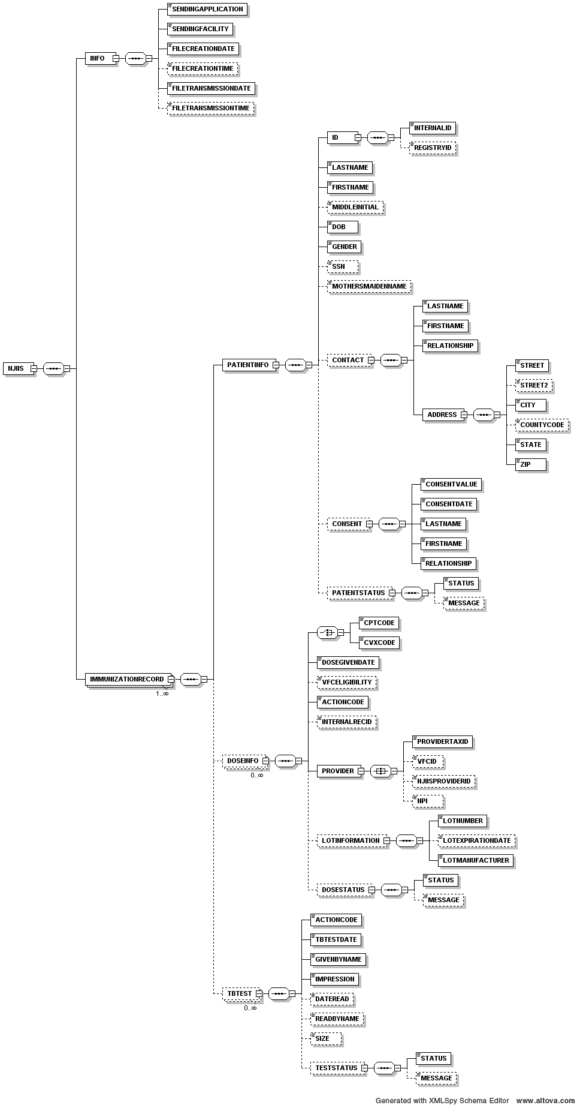

Delimited File Specification

The data file contains data in a tilde-delimited format (~), one line per shot.
The file encoding should be ASCII.
Transmission modes are SFTP and HTTPS POST.
Below are the fields to be included in the submitted file.

 | Field Name | Value / Required /  Optional? | Notes
1 | Patient Internal Id | R | Sending organization’s identifier for patient (e.g. chart number).
2 | Patient Registry Id | O | NJIIS identifier for patient. Must be a number.
3 | Patient Last Name | R
4 | Patient First Name | R
5 | Patient Middle Initial | O
6 | Patient Date of Birth | R | Formatted as mm/dd/yyyy
7 | Patient Gender | R | Allowed values are M, F, and U
8 | Patient Social Security Number | O | Formatted as 123-45-6789
9 | Patient Mother’s Maiden Last Name | O
10 | Patient Contact Last Name | See notes column | Required if providing contact information. Leave blank otherwise.
11 | Patient Contact First Name | See notes column | Required if providing contact information. Leave blank otherwise.
12 | Patient Contact Relationship | See notes column | Required if providing contact information. Leave blank otherwise. See Contact Relationship table for codes
13 | Patient Contact Address Street | See notes column | Required if providing contact information. Leave blank otherwise.
14 | Patient Contact Address Street2 | O
15 | Patient Contact Address City | See notes column | Required if providing contact information. Leave blank otherwise.
16 | Patient Contact Address County Code | O | See table for NJ County Codes.
17 | Patient Contact Address State | See notes column | Required if providing contact information. Leave blank otherwise. See table for state codes.
18 | Patient Contact Address Zip | See notes column | Required if providing contact information. Leave blank otherwise. 5 digit zip code only.
19 | Patient Consent Value | See notes column | Required if providing consent information. Leave blank otherwise. Allowed values are Y and N.
20 | Patient Consent Date | See notes column | Required if providing consent information. Leave blank otherwise. Formatted as mm/dd/yyyy
21 | Patient Consent Last Name | See notes column | Required if providing consent information. Leave blank otherwise.
22 | Patient Consent First Name | See notes column | Required if providing consent information. Leave blank otherwise.
23 | Patient Consent Relationship | See notes column | Required if providing consent information. Leave blank otherwise. See Consent Relationship table for codes.
24 | Dose CPT Code | See notes column | Leave blank if using a CVX code. Required otherwise.
25 | Dose CVX Code | See notes column | Leave blank if using a CPT code. Required otherwise.
26 | Dose Received Date | R | Formatted as mm/dd/yyyy
27 | Dose VFC Eligibility | O | See VFC Eligibility Codes table.  This field is required if sending facility wants to use this transmission for VFC Program accountability.
28 | Dose Action Code | R | Allowed values are A and D.
29 | Dose Internal Record Id | O | Sending entity identifier for shot.
30 | Dose Provider Tax Id | O | Only digits allowed. If unknown, specify 99999 and specify 417 in field 32 (Dose NJIIS Provider Id).
31 | Dose Provider VFC Id | O | Only digits allowed.
32 | Dose NJIIS Provider Id | O | Only digits allowed. If specified, fields 30 and 31 are ignored.
33 | Dose Lot Number | See notes column | Lot information, in general, is Optional. But if choose to provide the lot information, the Lot Number and Lot Manufacturer are required fields, but Lot Expiration Date can be optional.
34 | Dose Lot Expiration Date | See notes column | Formatted as mm/dd/yyyy.
35 | Dose Lot Manufacturer | See notes column | See vaccine Manufacturer table for codes. May use NJIIS code or abbreviation.
36 | NPI | O | NPI identifying provider administering this dose. Must be a 10-digit number.

HL7 File Specification

Use HL7 version 2.3.1 or higher specification Unsolicited Vaccination Record Update (VXU^V04).
Transmission modes are SFTP and HTTPS POST.
Latest version of HL7 specification and other related tables and documents can be found at http://www.cdc.gov/vaccines/programs/iis/default.htm
Below are the fields to be included in the submitted file.

 | Field Name | Value / Required /  Optional? | HL7  Segment.Field | Notes
1 | Patient Internal Id | R | PID.3 | Sending organization’s identifier for patient (e.g. chart number).
2 | Patient Registry Id | O | PID.4 | NJIIS identifier for patient. Must be a number.
3 | Patient Last Name | R | PID.5
4 | Patient First Name | R | PID.5
5 | Patient Middle Initial | O | PID.5
6 | Patient Date of Birth | R | PID.7 | Formatted as yyyymmdd
7 | Patient Gender | R | PID.8 | Allowed values are M, F, and U
8 | Patient Mother’s Maiden Last Name | O | PID.6
9 | Patient Contact Last Name | See notes column | NK1.2 | Required if providing contact information. Leave blank otherwise.
10 | Patient Contact First Name | See notes column | NK1.2 | Required if providing contact information. Leave blank otherwise.
11 | Patient Contact Relationship | See notes column | NK1.3 | Required if providing contact information. Leave blank otherwise. See Contact Relationship table for codes
12 | Patient Contact Address Street | See notes column | NK1.4 | Required if providing contact information. Leave blank otherwise.
13 | Patient Contact Address Street2 | O | NK1.4
14 | Patient Contact Address City | See notes column | NK1.4 | Required if providing contact information. Leave blank otherwise.
15 | Patient Contact Address County Code | O | NK1.4 | See table for NJ County Codes.
16 | Patient Contact Address State | See notes column | NK1.4 | Required if providing contact information. Leave blank otherwise. See table for state codes.
17 | Patient Contact Address Zip | See notes column | NK1.4 | Required if providing contact information. Leave blank otherwise. 5 digit zip code only.
18 | Patient Consent Value | See notes column | PD1.12 | Required if providing consent information. Leave blank otherwise. Allowed values are Y and N.
19 | Patient Consent Date | See notes column | PD1.13 | Required if providing consent information. Leave blank otherwise. Formatted as yyyymmdd
20 | Patient Consent Last Name | See notes column | NK1.2 | Required if providing consent information. Leave blank otherwise.
21 | Patient Consent First Name | See notes column | NK1.2 | Required if providing consent information. Leave blank otherwise.
22 | Patient Consent Relationship | See notes column | NK1.3 | Required if providing consent information. Leave blank otherwise. See Consent Relationship table for codes.
23 | Dose CPT Code | See notes column | RXA.5 | Leave blank if using a CVX code. Required otherwise.
24 | Dose CVX Code | See notes column | RXA.5 | Leave blank if using a CPT code. Required otherwise.
25 | Dose Received Date | R | RXA.3, RXA.4 | Formatted as yyyymmdd
26 | Dose VFC Eligibility and VFC Eligibility Effective Date | O | PV1.20 | Use HL7 table.  Both fields are required if sending facility wants to use this transmission for VFC Program accountability. Date should match dose received date.
27 | Dose Action Code | R | RXA.21 | Allowed values are A and D.
28 | Dose Provider Tax Id | O | RXA.10 | Only digits allowed. If unknown, specify 99999. See line 31 for History doses
29 | Dose Provider VFC Id | O | RXA.10 | Only digits allowed.
30 | Dose NJIIS Provider Id | O | RXA.10 | Only digits allowed.
31 | Dose given by another provider (History doses) | See notes column | RXA.9 | Use HL7 table.  Required if sending facility wants to send doses given at their office and at other facility for complete immunization record
32 | Dose Lot Number | See notes column | RXA.15 | Lot information, in general, is Optional. But if choose to provide the lot information, the Lot Number and Lot Manufacturer are required fields, but Lot Expiration Date can be optional.
33 | Dose Lot Expiration Date | See notes column | RXA.16 | Formatted as yyyymmdd
34 | Dose Lot Manufacturer | See notes column | RXA.17 | Use HL7 table for codes.

HEDIS File Specification

HEDIS sends Patients and demographic information to NJIIS and NJIIS sends back the Immunizations data to HEDIS.

HEDIS XML Format

Patient List (input)

Following is the schema file used to validate incoming files for Patients.

<?xml version="1.0" encoding="UTF-8"?>
<xs:schema xmlns:xs="http://www.w3.org/2001/XMLSchema" elementFormDefault="qualified" attributeFormDefault="unqualified">
<xs:element name="patientlist">
<xs:complexType>
<xs:sequence>
<xs:element name="patient" maxOccurs="unbounded">
<xs:complexType>
<xs:sequence>
<xs:element name="id" type="nbstring"/>
<xs:element name="firstname" type="nbstring"/>
<xs:element name="lastname" type="nbstring"/>
<xs:element name="dob" type="DateType"/>
<xs:element name="gender" type="GenderType"/>
<xs:element name="ssn" type="SSNType" minOccurs="0"/>
<xs:element name="mothersname" type="xs:string" minOccurs="0"/>
</xs:sequence>
</xs:complexType>
</xs:element>
</xs:sequence>
</xs:complexType>
</xs:element>
<xs:simpleType name="nbstring">
<xs:restriction base="xs:string">
<xs:minLength value="1"/>
</xs:restriction>
</xs:simpleType>
<xs:simpleType name="SSNType">
<xs:restriction base="nbstring">
<xs:pattern value="\d{3}-\d{2}-\d{4}"/>
</xs:restriction>
</xs:simpleType>
<xs:simpleType name="GenderType">
<xs:restriction base="nbstring">
<xs:enumeration value="M"/>
<xs:enumeration value="F"/>
<xs:enumeration value="U"/>
</xs:restriction>
</xs:simpleType>
<xs:simpleType name="DateType">
<xs:restriction base="nbstring">
<xs:pattern value="\d{2}/\d{2}/\d{4}"/>
</xs:restriction>
</xs:simpleType>
</xs:schema>

Vaccination List (output)

Following is the schema file used to produce outgoing files for Vaccinations.

<?xml version="1.0" encoding="UTF-8"?>
<!-- edited with XMLSpy v2006 U (http://www.altova.com) by gene (Financial Services) -->
<!-- edited with XMLSPY v5 rel. 2 U (http://www.xmlspy.com) by gene (none) -->
<xs:schema xmlns:xs="http://www.w3.org/2001/XMLSchema" elementFormDefault="qualified" attributeFormDefault="unqualified">
<xs:element name="patientlist">
<xs:complexType>
<xs:sequence>
<xs:element name="patient" minOccurs="0" maxOccurs="unbounded">
<xs:complexType>
<xs:sequence>
<xs:element name="id" type="nbstring"/>
<xs:element name="firstname" type="nbstring"/>
<xs:element name="lastname" type="nbstring"/>
<xs:element name="dob" type="DateType"/>
<xs:element name="vaccination" minOccurs="0" maxOccurs="unbounded">
<xs:complexType>
<xs:attribute name="cptcode" type="nbstring"/>
<xs:attribute name="vaccinationdate" type="DateType"/>
<xs:attribute name="provider_tax_id" type="xs:string"/>
<xs:attribute name="provider_name" type="xs:string"/>
</xs:complexType>
</xs:element>
<xs:element name="primary_provider_tax_id" type="xs:string" minOccurs="0"/>
<xs:element name="primary_provider_name" type="xs:string" minOccurs="0"/>
</xs:sequence>
</xs:complexType>
</xs:element>
</xs:sequence>
</xs:complexType>
</xs:element>
<xs:simpleType name="nbstring">
<xs:restriction base="xs:string">
<xs:minLength value="1"/>
</xs:restriction>
</xs:simpleType>
<xs:simpleType name="DateType">
<xs:restriction base="nbstring">
<xs:pattern value="\d{2}/\d{2}/\d{4}"/>
</xs:restriction>
</xs:simpleType>
</xs:schema>

HEDIS CSV Format

Input is same for both (7 fields)

The data file contains data in a tilde-delimited format (~), one line per shot.
The file encoding should be ASCII.
Transmission modes are SFTP and HTTPS POST.
Below are the fields to be included in the submitted file.

 | Field Name | Value  Required/  Optional? | Notes
1 | Patient Internal Id | R | Sending organization’s identifier for patient (e.g. chart number)
2 | Patient First Name | R
3 | Patient Last Name | R
4 | Patient Date of Birth | R | Formatted as mm/dd/yyyy
5 | Patient Gender | R | Allowed values are M, F, and U
6 | Patient Social Security Number | O | Formatted as 123-45-6789
7 | Patient Mother’s Maiden Last Name | O

HEDIS CSV with Provider Info Format

Output is of vaccination data either with Provider info OR without Provider info.

 | Field Name | Value  Required/  Optional? | Notes
1 | Patient Internal Id | R | Sending organization’s identifier for patient (e.g. chart number)
2 | Patient First Name | R
3 | Patient Last Name | R
4 | Patient Date of Birth | R | Formatted as mm/dd/yyyy
5 | Patient Gender | R | Allowed values are M, F, and U
6 | Patient Social Security Number | O | Formatted as 123-45-6789
7 | Patient Mother’s Maiden Last Name | O
8 | Provider Tax Id | O | Only digits allowed. If unknown, specify 417.
9 | Dose Lot Number | See notes column | Lot information, in general, is Optional. But if choose to provide the lot information, the Lot Number and Lot Manufacturer are required fields, but Lot Expiration Date can be optional.
10 | Dose Lot Expiration Date | See notes column | Formatted as mm/dd/yyyy.
11 | Dose Lot Manufacturer | See notes column | See vaccine Manufacturer table for codes. May use NJIIS code or abbreviation.

NJIIS Screens for Interface File Upload

Log in to NJIIS http://njiis.nj.gov/njiis/ using NJIIS User Name/Password.

If you are existing NJIIS user, first select the appropriate provider from the drop down on “Search for Patient” page and then click on “Upload Data” link under “Interface upload” title on the left navigation bar. The system will display “Interface File Upload” page.

If you are an Interface user, the system will direct you to the “Interface File Upload” page after log in.

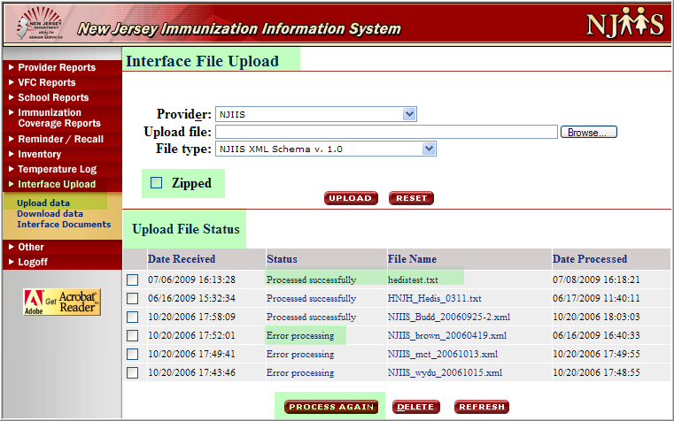
Figure 1: Interface File Upload and Upload File Status screen

Top portion of the page will allow you to upload your file. Use “Browse” button to select the file from your local directory and “Upload” button to load the file into NJIIS. Zip file should not be encrypted and should be in the root-directory only, not in any sub-directory folders.

Uploaded files placed in queue, as they received, and processed automatically. The file process outcome status could be either “Processed Successfully” or “Error Processing”.

For history purposes, files with “Processed Successfully” status cannot be deleted from the list.

Bottom portion of the page will display a list of all previously processed files.

To view file process statistics click on “Processed successfully” hyperlink next to the file name. You can select any file to “Process Again”, if needed, but the initial statistics will be changed. To view the initial input file, click on “File Name” hyperlink. To view processing errors click on “Error processing” hyperlink next to the file name.

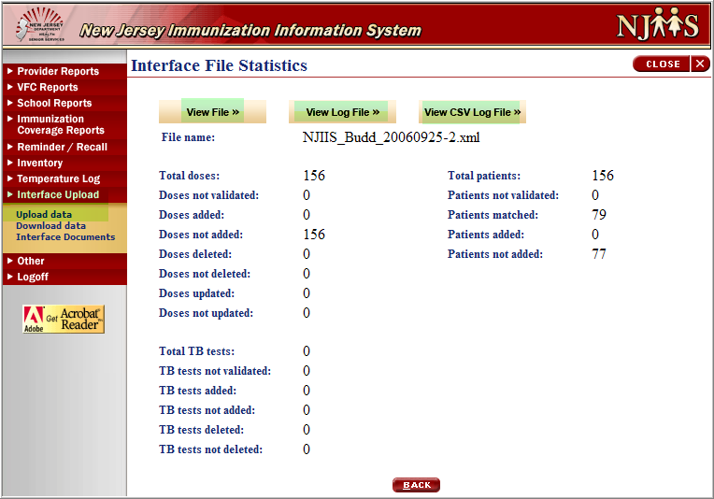
Figure 2: Interface File Statistics screen

To view the initial input file from “Interface File Statistics” screen click on “View File” button. The following page will display.

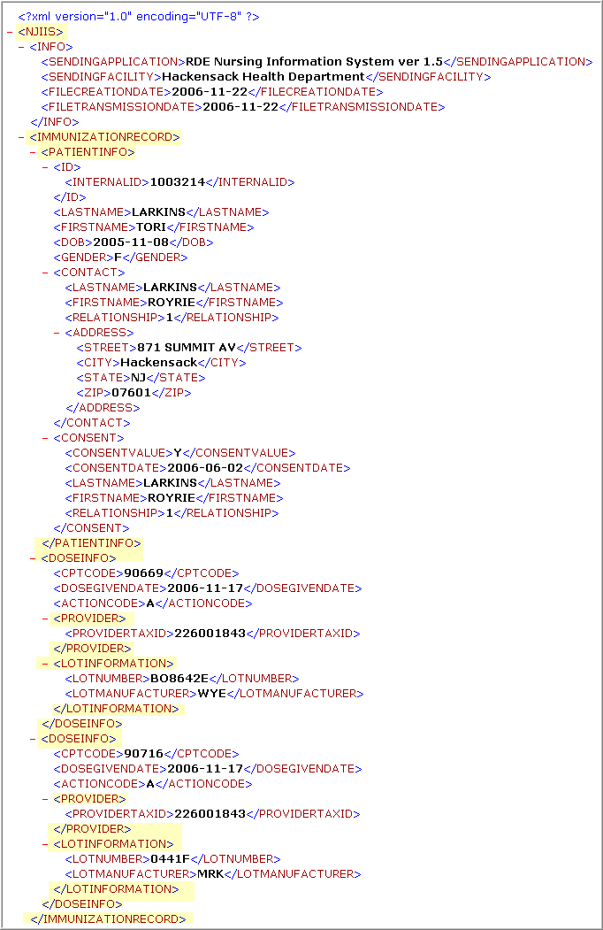
Figure 3: Interface File Statistics “View File” screen

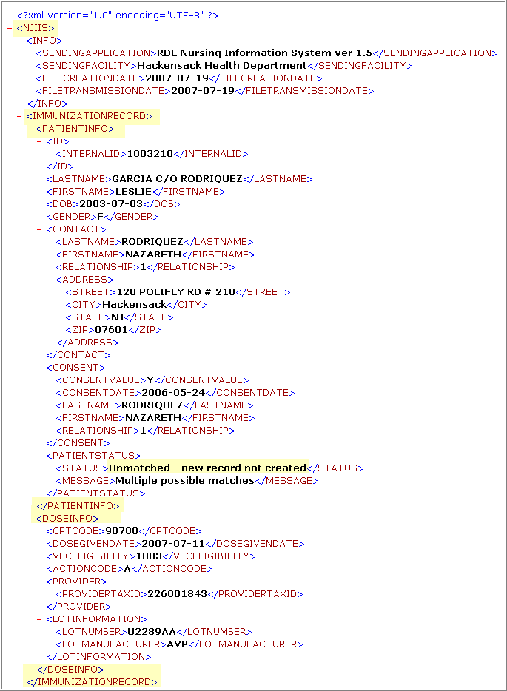
Figure 4: Interface File Statistics “View Log File” screen

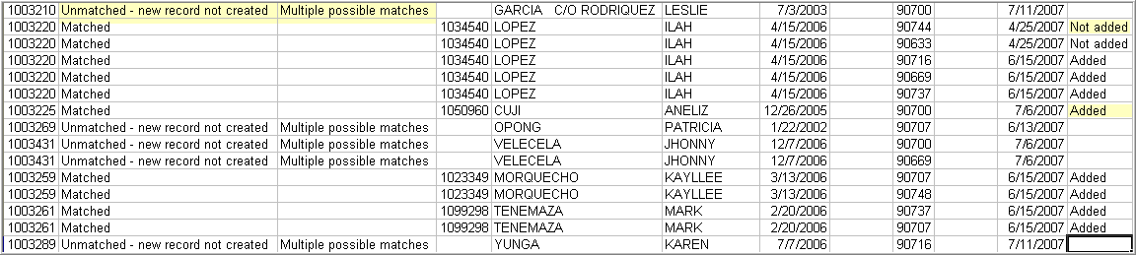
Figure 5: Interface File Statistics “View CSV Log File” screen

The status of “Error Processing” on “Upload File Status” screen is a hyperlink which will give you the error screen.

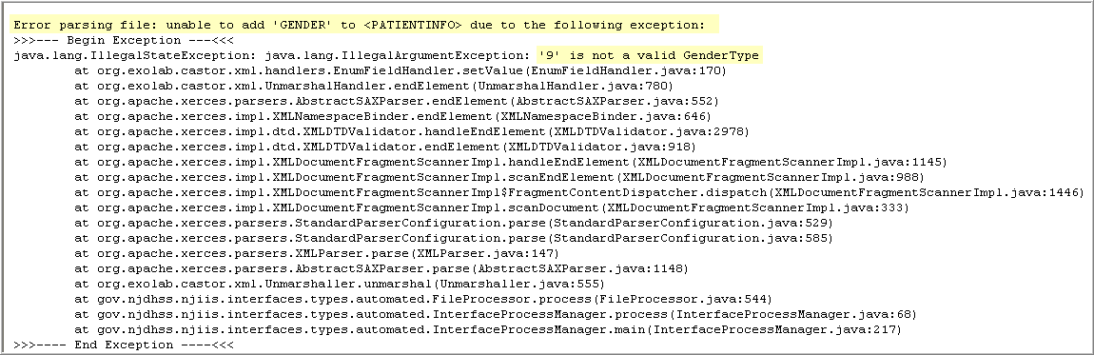
Figure 6: Error Processing screen
Figure 7: Error Processing screen

Depending on the Provider and the File Type, you will get different screens for statistics.

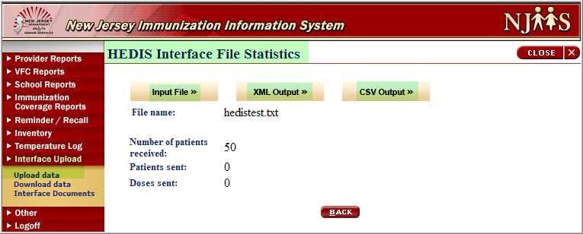
Figure 8: HEDIS Interface File Statistics screen

The “File Name” on “Upload File Status” screen is also a hyperlink, thru which you will get the following screen. The same screen you will also get when you click on “Input File” button from “HEDIS Interface File Statistics” screen and it will display which input file was submitted to NJIIS through the upload.

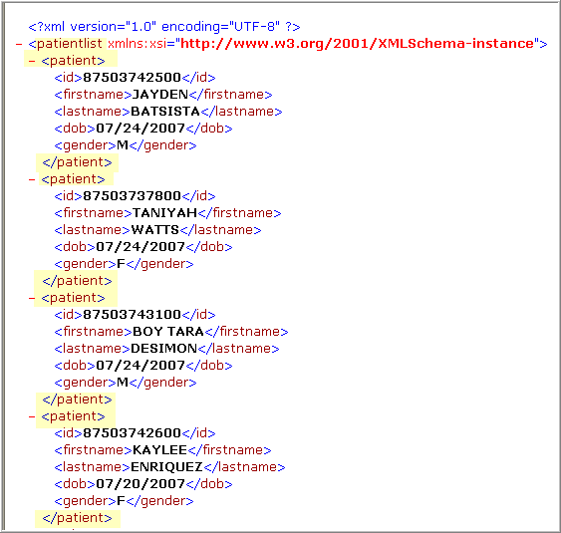
Figure 9:HEDIS Interface File Statistics “Input File” screen

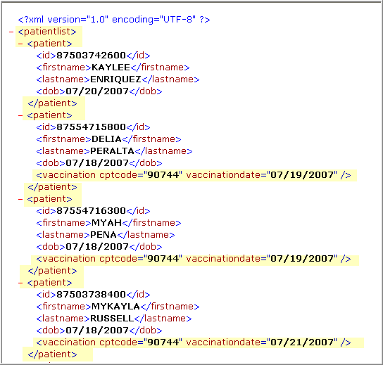
Figure 10: HEDIS Interface File Statistics “XML Output File” screen

Automated HTTP POST Data Submission Specification

URL to POST data files: https://njiis.nj.gov/njiis/InterfaceUploadServlet

POST Fields:

Name | Value
uploadmode | “AUTOMATIC”
filetype | “1” = NJIIS XML Schema V. 1.0  “5” = Delimited Immunization Upload  “2” = HEDIS XML Input  “3” = HEDIS CSV Input  “4” = HEDIS CSV with Provider Info
user | NJIIS user name
password | NJIIS password for user
providername | NJIIS provider ID for user (supplied by NJIIS)
zip | “TRUE” if file zipped, omit field otherwise
file1 | Data File.

URL to retrieve log files: https://njiis.nj.gov/njiis/InterfaceFileServlet

Fields:

Name | Value
automode | “TRUE”
user | NJIIS user name
password | NJIIS password for user
provider | NJIIS provider ID for user (supplied by NJIIS)
l | Upload ID returned during file submission (If submitting XML data and retrieving log file)
delx | Upload ID returned during file submission (If submitting delimited data and retrieving XML log file)
delc | Upload ID returned during file submission (If submitting delimited data and retrieving delimited log file)
e | Upload ID returned during file submission (If retrieving error file)

Please do not submit interface files without prior arrangement and approval.
Attachments

New Jersey Counties

COUNTY_CODE | COUNTY_NAME
34001 | ATLANTIC
34003 | BERGEN
34005 | BURLINGTON
34007 | CAMDEN
34009 | CAPE MAY
34011 | CUMBERLAND
34013 | ESSEX
34015 | GLOUCESTER
34017 | HUDSON
34019 | HUNTERDON
34021 | MERCER
34023 | MIDDLESEX
34025 | MONMOUTH
34027 | MORRIS
34029 | OCEAN
34031 | PASSAIC
34033 | SALEM
34035 | SOMERSET
34037 | SUSSEX
34039 | UNION
34041 | WARREN

CPT Codes

Please refer to CDC’s CPT code table for latest valid CPT codes.

http://www2a.cdc.gov/nip/IIS/IISStandards/vaccines.asp?rpt=cpt

CVX Codes

Please refer to CDC’s CVX code table for latest valid CVX codes.

http://www2a.cdc.gov/nip/IIS/IISStandards/vaccines.asp?rpt=cvx

Manufacturer Codes

Please refer to CDC’s Manufacturer code table for latest valid Manufacturer codes.

http://www2a.cdc.gov/nip/IIS/IISStandards/vaccines.asp?rpt=mvx

VFC Eligibility Codes

CODE | VFC ELIGIBILITY
1001 | Medicaid, Medicaid Managed Care, and NJ KidCare Plan A
1002 | NJ KidCare Plans B,C & D
1003 | has no health insurance
1004 | is an American Indian or Alaskan Native
1005 | has health insurance that does not pay for vaccine *(NOTE: These individuals can only receive vaccine provided through the VFC Program at a FQHC such as a community/migrant/rural health center.)
1006 | 317 funds *(NOTE: Only available to local health department operated sites if the five eligibility criteria listed above are not met, or by special permission of the N.J. Immunization Program.)
1007 | Not eligible
1008 | Not Available

Relationships Codes

Contact relationship codes

CODE | DESCRIPTION
0 | UNKNOWN
1 | MOTHER
2 | FATHER
3 | AUNT
4 | GRANDMOTHER
5 | GRANDFATHER
6 | FOSTER CARE
7 | UNCLE
8 | LEGAL GUARDIAN
9 | SELF

Consent relationship codes

CODE | DESCRIPTION
1 | MOTHER
2 | FATHER
3 | LEGAL GUARDIAN
4 | SELF

